H.T No
Regulations:
A22

Sreenidhi Institute of Science and Technology
(An Autonomous Institution)
Code No:9AC48 Date: 09-August-2024 (FN)

B.Tech I-Year II- Semester External Examination, August-2024 (Regular & Supplementary)
BASIC ELECTRICAL AND ELECTRONICS ENGINEERING (CSE,IT,CS,AIML,DS,IOT)

Time: 3 Hours Max.Marks:60

Note: a) No additional answer sheets will be provided.
b) All sub-parts of a question must be answered at one place only, otherwise it will not be valued.
c) Missing data can be assumed suitably.
Bloom's Cognitive Levels of Learning (BCLL)

Remember | L1 | Apply | L3 | Evaluate | L5
Understand | L2 | Analyze | L4 | Create | L6

Part - A Max.Marks: 6x2=12

Answer all QUESTIONS, EACH QUESTION CARRIES 2 MARKS.

 |  | BCLL | CO(s) | Marks
1 | What is the current in 5 ohm Resistor?  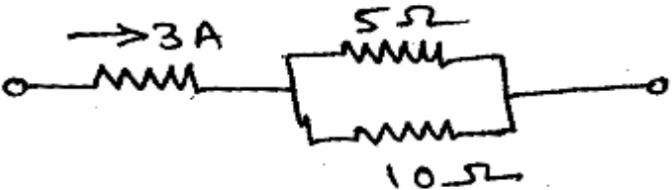 | L1 | CO1 | [2M]
2 | Write is the relationship between line phase values Voltage and current in delta connected three-phase, balanced system. | L1 | CO2 | [2M]
3 | List the main parts of three phase induction motor? | L1 | CO3 | [2M]
4 | Draw the V-I characteristics of PN Junction Diode . | L2 | CO4 | [2M]
5 | List out the uses of BJT. | L2 | CO5 | [2M]
6 | Write 2’s complement of (1000)₂ | L1 | CO6 | [2M]

Part – B Max.Marks: 6x8=48
ANSWER ALL QUESTIONS. EACH QUESTION CARRIES 8 MARKS.

 |  | BCLL | CO(s) | Marks
7. | State Superposition Theorem and By using Superposition Theorem determine value of current (I) through 6 ohms resistor in the given circuit shown in Figure-1.  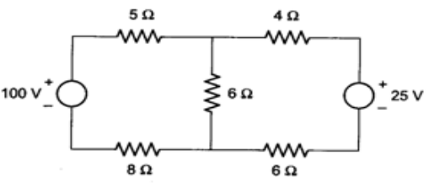  Figure-1. | L3 | CO1 | [8M]
 | OR
8 | Explain basic construction and principle of operation of DC generator in detail with its applications. | L2 | CO1 | [8M]
9. | i)Define the terms : a) cycle , b) Time period c) form factor d) Peak factor  ii)An alternating current is given by i = 20 sin 600t Amp. Calculate the frequency, peak value of current and the time taken t for the current to reach value of 10A. | L2  L3 | CO2 | [8M]
 | OR
10 | An impedance Z₁=(2.4 + j3.2) ohm is in parallel with another impedance Z₂=(3-j4) ohm .The combination is given a supply of 200V. Calculate the total impedance, current supplied by source, current through individual branches, power factor and power consumed in the circuit. | L3 | CO2 | [8M]
11 | i)Explain the concept of Faraday’s laws.  ii)Explain the principle of operation of three phase induction motor. | L2  L2 | CO3 | [8M]
 | OR
12 | i)List out the classification of measuring instruments.  ii)Compare Moving coil Instruments and moving Iron Instruments in any four aspects. | L2  L2 | CO3 | [8M]
13 | i)Describe the operation of full wave rectifier with neat sketch and its wave forms.  (ii) Explain the operation of PN junction diode in forward bias and reverse bias mode. | L2  L2 | CO4 | [8M]
 | OR
14 | i)Describe the VI-characteristics of Zener diode under reverse biased mode.  ii)Write short notes on clippers and clampers | L2  L2 | CO4 | [8M]
15 | Explain the input and output characteristics of the transistor in Common base configuration with diagrams. | L3 | CO5 | [8M]
 | OR
16 | Explain the construction and working operation of n channel JFET. | L2 | CO5 | [8M]
17 | i)Convert the following numbers :  (a) (FE7)₁₆ = ( )₁₀ (b) (753)₁₀ = ( )₈  ii)Describe about weighted and unweighted codes. | L3  L2 | CO6 | [8M]
 | OR
18 | Draw the different logic gates with truth tables. | L2 | CO6 | [8M]

-- 00 -- 00 –

